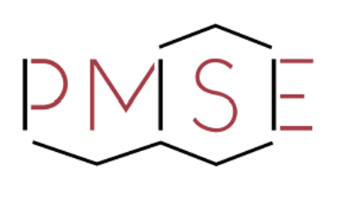

BREAKTHROUGH IN POLYMERS FORUM
August 24, 2026 – Chicago, IL

Purpose
Breakthrough in Polymers (BIP) Forum aims to advance professional development of early career polymer scientists and engineers and to enhance interactions between emerging leaders from government labs, industry and non-academic organizations by bringing them together to discuss current challenges and opportunities in polymer science, materials and engineering. Industrial, academic and government leaders will share valuable experiences and ideas with selected invited participants fostering breakthrough and diverse thinking regarding leading-edge polymer research topics.

Rules of Eligibility
- Invited participants will be early career scientists and engineers from industry, government or other non-academic research organizations.
- All participants need to be members of ACS and the PMSE Division at the time of the nomination and the meeting.
- PMSE defines “early-career scientist or engineer” as a member who is no more than 7 years beyond the start of their independent research career (postdoc period is included in this 7 years).
- Participants do not need to have expertise in the topics to be discussed.

Nomination Process
- The nomination period ends on March 16, 2026.
- All nominees need to be members of ACS and the PMSE Division.
- Peer and self-nominations are accepted.
- The selection committee will be composed of PMSE volunteers.
- Individuals from groups historically underrepresented in STEM are highly encouraged to apply.

Invited Participant Selection Criteria
- Significant contributions to polymer science and engineering during their research.
- History of active participation in Scientific Communities within their organizations or externally.
- Initiation and leadership of projects that contribute to advancement in polymer science and engineering
- Mentoring, coaching and inspiring next-generation researchers in polymer science, materials and engineering.
- Diverse polymer research background.
- Participants will be selected via a nomination process.
- Nominations will be reviewed by a peer committee composed of PMSE volunteers
- Selected participants will receive a formal invitation to be part of the inaugural BIP class.

Announcement and Nature
- The selection committee will start sending invitations to invited members of the inaugural class by March 23, 2026, and invited participants will need to confirm their participation by April 15, 2026.
- Invited participants are expected to present a poster during the forum. Poster abstracts need to be submitted per the instructions in the invitation letter. Poster topics can be about participants’ current research, their work field, or their student research topic.
- PMSE will provide reimbursement for registration fees and one night of hotel stay for participants up to $850 per participant, if requested.
- Transportation to the conference will need to be covered by the participant or the participant’s organization.

Nomination Form

Please use the following format when you submit the nomination
Document Type: PDF
Naming Convention for the Nomination Package: 2026-BIP Forum Nomination (Last Name, First Name)
Send Nomination Package to: PMSEBIP@gmail.com
E-mail Subject: 2026-BIP Forum Nomination (Last Name, First Name)

Submission Date

Nominee
Nominee Name / Last Name
Is Nominee an ACS / PMSE member?
Nominee ACS Member Number
Nominee’s Employer
Nominee’s Title
Undergraduate Degree
Highest Degree
School where last degree is earned
How many years since graduation (from the highest degree - included postdoc)?
Nominee’s Work Email
Nominee’s Phone Number

Nominator
Nominator Name / Last Name
Is Nominator an ACS / PMSE member?
(Nominator doesn’t have to be a member)
Nominator’s ACS Member Number
Nominator’s Employer
Nominator’s Title
Nominator’s E-mail
Nominator’s Phone Number
Relationship with the Nominee (Supervisor, Peer, Research Advisor, Professor etc.)
Nominator’s Signature

Nomination Letter (Max 500 words)
Please describe why you think this nominee would be an outstanding participant to inaugural Breakthrough in Polymers Forum based on the Criteria.

Please list an additional reference and attach supporting nomination letter (Max 500 words)
Name / Last Name:
Employer / Title:
E-mail:
Phone:

Please add or attach Nominee’s Resume / CV below (no more than 5 pages)

